**How to create a Twitter App:**

The basic steps to use Twitter App

1. Register the application. (<https://apps.twitter.com/> )
2. Include your callback URL. (This is not a required field so you can ignore. )

This is where the Twitter OAuth API will respond with the correct credentials for your application once the user signs in. It will receive a token that can be stored; this can be changed later

1. Click submit.
2. On the application page, click the “Keys and Access Tokens” tab.

Retrieving those tokens enables your application to access the OAuth API.

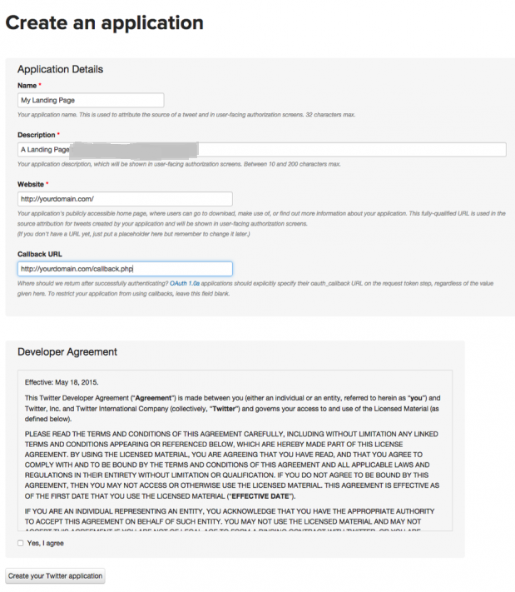

**Things required to connect to your APP**From Above steps 4 please copy the keys that are used in the app

* Consumer Key
* Consumer Secret
* OAuth access token
* OAuth access token secret